ASSIGNMENT 1 – CO1
ARTIFICIAL INTELLIGENCE – CSA17
Design, Analyse and Validate an Efficient Search Strategy
for a Hospital Medicine-Delivery Robot

Abstract
This assignment designs and evaluates three uninformed search strategies for a hospital medicine-delivery robot: Breadth-First Search (BFS), recursive Depth-First Search (DFS), and Uniform-Cost Search (UCS). The work defines the agent and environment, formulates the search problem, identifies basic operations, derives complexity and a recurrence, analyses best/average/worst cases, and validates the implementations using repeatable experiments at 1,000, 10,000, 100,000 and 1,000,000 states. The Day-4 challenge is addressed by representing uncertain robot locations as belief states and evaluating the effect of local sensing. The measurements are generated by the included Python 3 scripts; timing values are machine-dependent and should be regenerated on the machine used for final submission.

Contents
1. Scenario and assumptions
2. Task 1 – Agent and algorithm design
3. Task 2 – Basic operations
4. Task 3 – Mathematical complexity derivation
5. Task 4 – Best, average and worst cases
6. Task 5 – Asymptotic analysis
7. Task 6 – Recurrence formulation
8. Task 7 – Recurrence solution
9. Task 8 – Implementation and testing
10. Task 9 – Experimental performance
11. Task 10 – Theory versus experiment
12. Task 11 – Final design recommendation
13. Task 12 – Day-4 design challenge
14. Conclusion
Appendix A – Source code and reproduction instructions

1. Scenario and assumptions
A multi-block hospital is represented as a graph. Vertices represent junctions, corridors, lift lobbies and ward doors; edges represent traversable connections. Every edge has a travel-time cost. The robot must find a route from the central pharmacy to a requested ward, and later return to the pharmacy docking station after localization becomes uncertain.
The supplied question specifies growth from 1,000 to 10,000, 100,000 and 1,000,000+ states. To keep the one-million-state experiment reproducible on ordinary Python installations, the experimental graph is an implicit complete binary tree. A state is represented by an integer; successors are calculated in constant time rather than storing one million separate adjacency lists. This is a deliberate representation choice, not a claim that every real hospital has a tree layout.
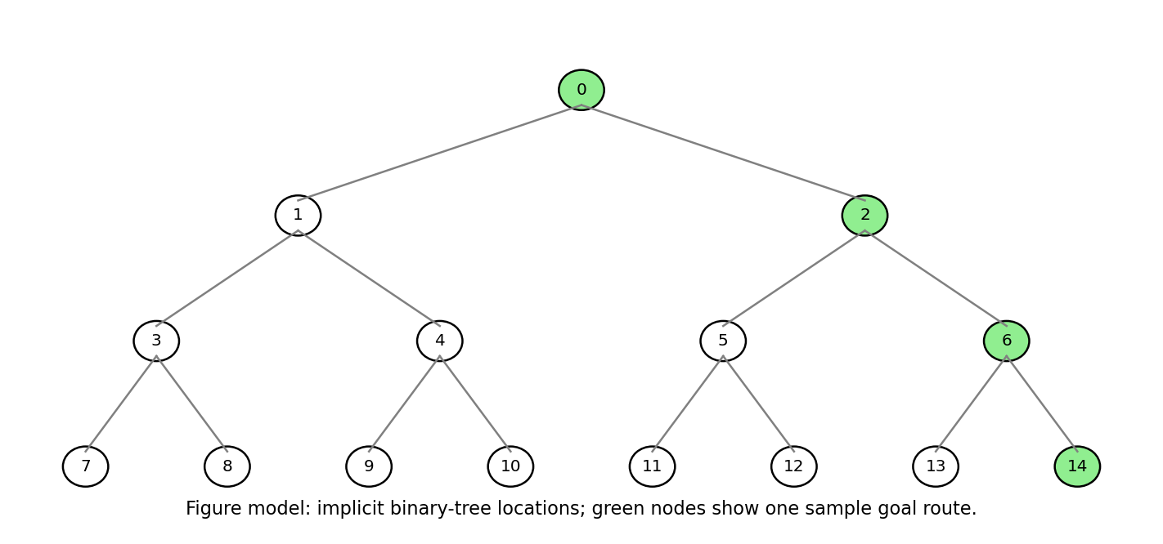
Figure 1. Example of the implicit hospital-location graph and one route.
Experimental assumptions: the graph structure and start/goal are fixed within each size; start is node 0; goal is node N−1; the random seed recorded in the results is 2026 (the graph itself is deterministic); the goal is reachable in the main scaling experiment; each algorithm is run five times; timing is averaged; generated/expanded counts and maximum frontier size are the primary evidence. The model assigns cost 1 to edges on the unique route to the goal and cost 100 to off-route edges. Since this tree has only one route between any two vertices, all found routes are optimal on this test graph. General optimality guarantees are discussed separately.

2. Task 1 – Design the agent and search algorithms (5 marks)

2.1 PEAS description
Table 1. PEAS description of the hospital robot.
PEAS element | Description
Performance measure | Correct delivery to the requested ward; low travel time; collision avoidance; reliable docking; low computation and memory use.
Environment | Hospital corridors, junctions, lifts, pharmacy, wards, people and temporary obstructions.
Actuators | Drive motors, steering, brakes, lift-call interface, medicine-compartment lock and status display.
Sensors | Wheel encoders, camera/LiDAR, proximity sensors, lift status, localization sensors and ward identifiers.

2.2 Environment classification
Table 2. Environment classification and justification.
Dimension | Classification | Justification
Observability | Normally partially observable in practice; fully observable in the baseline graph model | The graph model provides the exact current node, while real sensors can fail or be occluded.
Determinism | Deterministic baseline; stochastic in the real hospital | A graph action has a defined successor in the experiment; people, doors and lifts can introduce uncertainty.
Episode structure | Sequential | Each move changes the robot position and affects future route choices.
Dynamics | Dynamic | People, doors, lift availability and blocked corridors can change while planning.
State/action representation | Discrete graph states and actions; physical motion is continuous | The search uses named junctions and edges, while actual motors operate continuously.
Agents | Multi-agent environment | The robot shares corridors with staff, patients, visitors and other robots.

2.3 AI view and rationality
The robot follows the “acting rationally” view of AI. It selects actions that are expected to achieve the goal while minimizing travel cost and respecting safety constraints. It is a problem-solving agent because it formulates a goal, searches a state space, compares candidate paths and executes a selected sequence. This connects with early symbolic AI work, where problems were represented as states and operators and solved through systematic search (for example, state-space search and general problem-solving methods).

2.4 Problem formulation
Table 3. Formal search-problem definition.
Component | Definition
State | A hospital location represented by integer node u in {0, …, N−1}.
Initial state | The pharmacy or current known robot location; in the baseline experiment, node 0.
Actions | Move to an adjacent parent/child junction in the implicit tree.
Transition model | For each legal adjacent node v, action move(u,v) changes the state from u to v.
Goal test | Current node equals the requested ward node; in the main experiment, N−1.
Path cost | Sum of edge travel costs along the route; experimental costs are 1 on the goal route and 100 on off-route edges.

2.5 Three distinct uninformed strategies

A. Breadth-First Search (BFS) – iterative queue
BFS removes the oldest frontier node first. It explores all nodes at depth 0, then depth 1, then depth 2, and so on. It is selected as a baseline because it is complete on a finite graph and finds a minimum-edge route when every step has equal cost. Its weakness is the potentially large frontier.

B. Recursive Depth-First Search (DFS)
Recursive DFS follows one successor as deeply as possible before backtracking. It is selected to satisfy a recursive strategy and to contrast stack memory with BFS frontier memory. It may find a deep route quickly if the goal lies on the first branch, but it is not generally optimal and can explore many states before finding the goal. A visited set prevents revisiting states in cyclic graphs.

C. Uniform-Cost Search (UCS) – priority queue
UCS removes the frontier node with the smallest accumulated path cost g(n). It is selected because the hospital edges have travel-time costs, so minimizing edge count alone may not minimize travel time. With strictly positive step costs, UCS is complete on a finite graph and returns a least-cost route. It can require substantial memory in a general graph, although the deliberately weighted experiment favors the low-cost goal route.
Preprocessing: the implicit graph uses integer labels and calculates neighbors on demand. The target-ancestor set used to assign edge costs requires O(log N) time and space. No O(V+E) adjacency-list construction is performed. For a production graph stored as adjacency lists, building the lists would cost O(V+E) time and O(V+E) memory and must be added to total cost.
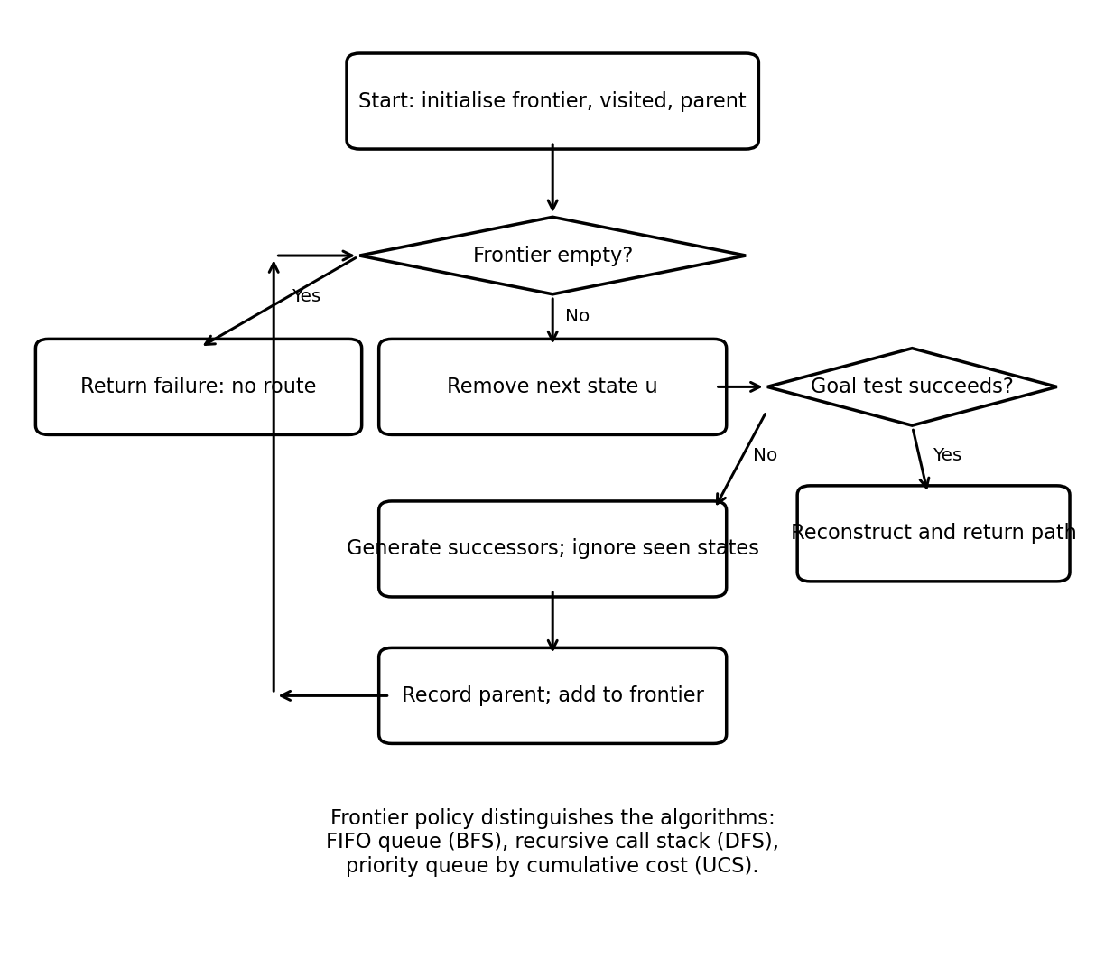
Figure 2. Generic search control flow; the frontier data structure determines BFS, DFS or UCS behaviour.

3. Task 2 – Identify the basic operation (2 marks)
Table 4. Basic operations for the selected algorithms.
Algorithm | Basic operation | Where it occurs and why it matters
BFS | Successor examination / first-time frontier insertion | For every expanded node, adjacent states are generated and checked against visited. Each newly discovered state is enqueued once. Counts track the main work and frontier growth.
Recursive DFS | Recursive successor call after visited check | The algorithm tests successors and descends recursively. Calls/expansions dominate runtime; the number depends on branch order and where the goal occurs.
UCS | Priority-queue insertion/removal and cost relaxation | Each expanded state examines edges and may update a best-known cost, causing heap operations. Heap maintenance costs O(log F) per insertion/removal for frontier size F.

As N grows, BFS may discover and queue a large fraction of the graph; DFS may make nearly one recursive call per state; UCS may expand fewer states when a low-cost route is strongly preferred, but in other weighted graphs it can process most reachable states and pay heap overhead. Therefore, operation counts are more informative than runtime alone.

4. Task 3 – Derive time and space complexity mathematically (6 marks)
Let b be the branching factor, d the depth of the shallowest goal, m the maximum depth, C* the optimal solution cost, and ε>0 the minimum edge cost. At level i of a full b-ary tree there are b^i nodes. Through depth d, the total number is:
S(d) = 1 + b + b² + … + bᵈ = (b^(d+1) − 1)/(b − 1), for b ≠ 1. Thus S(d) = Θ(bᵈ) for b>1. In a finite graph with V states and E edges, duplicate detection bounds first-time expansion by O(V) and edge examination by O(E).

4.1 BFS
BFS expands all levels before the goal depth, and may examine all nodes at depth d before the goal is selected. Worst-case generated nodes are approximately Σ(i=0 to d+1)b^i = (b^(d+2)−1)/(b−1), hence O(b^(d+1)); the conventional tree-search bound is O(b^(d+1)) time. In a finite graph with visited-set duplicate detection, time is O(V+E). The queue may hold an entire level, so frontier memory is O(b^(d+1)) in the tree bound, or O(V) in a finite graph; parent and visited structures also use O(V).

4.2 Recursive DFS
DFS may inspect nodes down to maximum depth m. In the worst case it visits every node in a full tree: W(m)=Σ(i=0 to m)b^i=(b^(m+1)−1)/(b−1), giving Θ(b^m) for b>1. Edge examinations are O(E) on a finite graph with duplicate detection. The active recursive call stack is O(m), but a visited set and parent map used to reconstruct the path add O(V) memory. Without those structures, tree-search auxiliary stack space is O(bm) for a conventional implementation; this assignment reports the actual implementation’s O(V) total storage because it records visited and parent states.

4.3 Uniform-Cost Search
UCS expands nodes in increasing path-cost order. Any node on a path with cost g(n)<C* must be considered before a goal of cost C* is removed. Since every edge costs at least ε, the depth of such nodes is at most floor(C*/ε). A tree bound on generated nodes is Σ(i=0 to floor(C*/ε)+1)b^i, which is O(b^(1+floor(C*/ε))). This is often written O(b^(1+⌊C*/ε⌋)). With a binary heap and E_r successful relaxations among reachable edges, heap work is O((V_r+E_r) log V_r) in a common graph implementation, plus neighbor examinations O(E_r). Space is O(V_r+E_r) for frontier, costs, closed set and parent links in the worst case.
Table 5. Derived complexity summary.
Algorithm | Time bound (tree-search form) | Memory bound (implementation-aware) | Main caveat
BFS | O(b^(d+1)); graph form O(V+E) | O(V) total; frontier can be O(b^(d+1)) | Large breadth can exhaust memory.
Recursive DFS | O(b^m); graph form O(V+E) | O(V) total here; recursion depth O(m) | Can spend time in a poor branch; not cost-optimal.
UCS | O(b^(1+⌊C*/ε⌋)) tree bound; graph heap bound O((V+E)log V) | O(V+E) worst case | Depends on cost distribution and priority-queue work.

Preprocessing is O(log N) time and space in the experiment because only the goal ancestor chain is stored. Total cost is preprocessing plus search: T_total(N)=O(log N)+T_search(N). The implicit successor calculation costs O(1) per expanded state. If explicit adjacency lists were used instead, add O(V+E) preprocessing time and memory.

5. Task 4 – Best, average and worst-case behaviour (4 marks)
Table 6. Best, average and worst-case conditions.
Algorithm | Best case | Average-case discussion | Worst case
BFS | Goal is start or a first-level successor; O(1) work. | Depends on goal depth and width of earlier levels; expected work is proportional to states preceding the goal in BFS order. | Goal is deepest/last in breadth order or unreachable; explores Θ(V) states in a finite connected graph.
Recursive DFS | Goal is start or on the first branch; O(d) calls. | Depends heavily on branch ordering; can visit a large fraction of nodes even when a short route exists elsewhere. | Goal is last in DFS order or unreachable; Θ(V) state visits and O(m) recursion depth.
UCS | Goal is start; or a uniquely cheap path is popped before costly alternatives. | Depends on the number of states whose best path cost is below C* and heap updates. | Many low-cost detours or many states with g(n)<C*; may process most states and incur heap overhead.

The terms “average case” require a probability distribution over graph structures, costs and goal placement. No such universal distribution is given in the assignment, so the table describes the factors that determine average behaviour rather than claiming a single numeric average-case formula.

6. Task 5 – Asymptotic analysis (3 marks)
For a finite graph with duplicate detection, BFS and DFS have Θ(V+E) worst-case traversal time when all reachable states and edges are examined. Their lower bound is Ω(1) for a start-equals-goal query; on a family where all states must be inspected, the traversal is Ω(V+E), so the full traversal is Θ(V+E). UCS has worst-case O((V+E) log V) with a binary heap, and may be Ω(1) for a trivial goal. The tree-search expressions show exponential growth in depth when b>1, while graph-based duplicate detection caps work by V and E.
When the hospital grows from 1,000 to 1,000,000 states, linear state/edge processing can grow by about 1,000×, while storing a frontier or parent/visited map can become the limiting factor before arithmetic becomes expensive. BFS is especially vulnerable to wide frontiers. DFS’s call stack can be small relative to V, but this implementation still stores visited and parent data. UCS may be more selective when costs strongly favor one route, but its heap and bookkeeping can become expensive when many states compete.

7. Task 6 – Formulate the recurrence relation (3 marks)
For recursive DFS on a full b-ary tree, let T(h) be the worst-case work when the remaining search depth is h and the goal is absent or last in traversal order. At a non-leaf node, DFS performs Θ(1) local work (goal test and loop overhead) and may recursively search each of b child subtrees of remaining depth h−1. Therefore:
T(h) = bT(h−1) + c, for h > 0; T(0) = c₀,
where b is the number of recursive child calls in the worst case, T(h−1) is the subproblem on one child subtree, c is constant local work, and c₀ is the base-case cost at a leaf. If the goal is found early, the recursion stops and actual work is smaller; the recurrence models the worst case.

8. Task 7 – Solve the recurrence relation (4 marks)
The iteration method is suitable because each recurrence call reduces the depth by one and creates b subproblems. Expand repeatedly:
For b>1, T(h)=Θ(b^h). If b=1, T(h)=Θ(h). This confirms that recursive DFS can grow exponentially with depth in a branching tree. For iterative deepening DFS (IDDFS), depth limits 0, 1, …, d are searched in turn. Nodes near the root are revisited, but the total remains Θ(b^d) for b>1 because the deepest level dominates the geometric sum; memory is O(bd) or O(d) active recursion plus small per-level state depending on duplicate handling. The repeated work is the trade-off for low memory.

9. Task 8 – Implement and test the algorithms (4 marks)
The full Python 3 implementations are included in Appendix A and in src/hospital_search.py. The graph is generated implicitly, so a million nodes do not require a million Python list objects. All algorithms use the same state labels and start/goal pair at each size. The main experiment is deterministic; seed 2026 is recorded for reproducibility, although no random graph edges are sampled.
Run from the repository root:
python src/hospital_search.py
python src/belief_state_challenge.py
Table 7. Functional test cases and observed behaviour.
Test case | Input | Expected behaviour | Observed result
Reachable | N=31, start=0, goal=30 | Return a valid path ending at 30. | All three algorithms found a route; BFS/DFS depth 4; UCS depth 4.
Start equals goal | N=31, start=7, goal=7 | Return [7] with zero moves. | All three returned a zero-depth solution.
Unreachable / invalid target | N=31, start=0, goal=40 | Return failure without crashing. | All three returned no path.

Expected behaviour means a route whose first state is the start and last state is the goal, or a clean failure for an invalid/unreachable target. The source script prints test summaries and writes the performance CSV. The output transcript is saved at results/console_output.txt.

10. Task 9 – Experimental performance (3 marks)
Each algorithm was run five times at each of four state-space sizes. Table 8 reports node counts and maximum frontier; Table 9 reports the measured mean time. Runtime is secondary because it depends on processor, Python version, background load and memory. Counts are the primary evidence.
Table 8. Search operation counts and route metrics.
States | Algorithm | Generated | Expanded | Max frontier | Depth | Path cost
1,000 | BFS | 1,000 | 500 | 500 | 9 | 9
1,000 | Recursive DFS | 981 | 981 | 10 | 9 | 9
1,000 | Uniform Cost Search | 18 | 9 | 9 | 9 | 9
10,000 | BFS | 10,000 | 5,000 | 5,000 | 13 | 13
10,000 | Recursive DFS | 3,626 | 3,626 | 14 | 13 | 13
10,000 | Uniform Cost Search | 26 | 13 | 13 | 13 | 13
100,000 | BFS | 100,000 | 50,000 | 50,000 | 16 | 16
100,000 | Recursive DFS | 68,940 | 68,940 | 17 | 16 | 16
100,000 | Uniform Cost Search | 32 | 16 | 16 | 16 | 16
1,000,000 | BFS | 1,000,000 | 500,000 | 500,000 | 19 | 19
1,000,000 | Recursive DFS | 951,438 | 951,438 | 20 | 19 | 19
1,000,000 | Uniform Cost Search | 38 | 19 | 19 | 19 | 19

Table 9. Mean runtime and standard deviation over five runs.
States | Algorithm | Mean time (s) | Population SD (s) | Runs
1,000 | BFS | 0.000419 | 0.000031 | 5
1,000 | Recursive DFS | 0.000663 | 0.000031 | 5
1,000 | Uniform Cost Search | 0.000019 | 0.000011 | 5
10,000 | BFS | 0.004584 | 0.000479 | 5
10,000 | Recursive DFS | 0.002879 | 0.000155 | 5
10,000 | Uniform Cost Search | 0.000025 | 0.000009 | 5
100,000 | BFS | 0.071328 | 0.005686 | 5
100,000 | Recursive DFS | 0.072817 | 0.007854 | 5
100,000 | Uniform Cost Search | 0.000064 | 0.000052 | 5
1,000,000 | BFS | 0.703173 | 0.124289 | 5
1,000,000 | Recursive DFS | 1.460576 | 0.234641 | 5
1,000,000 | Uniform Cost Search | 0.000038 | 0.000014 | 5

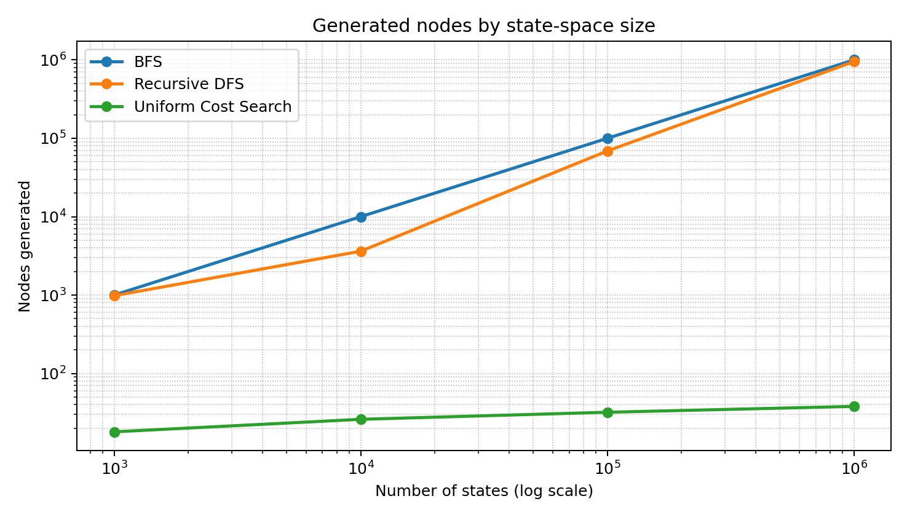
Figure 3. Nodes generated across state-space sizes (log-log axes).
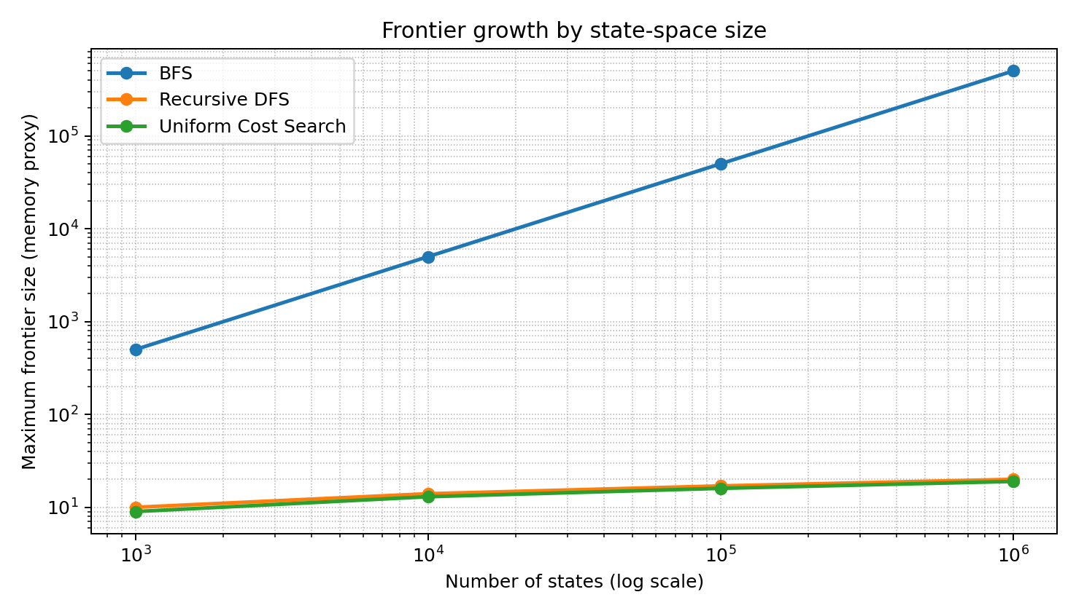
Figure 4. Maximum frontier size, used as a memory proxy (log-log axes).
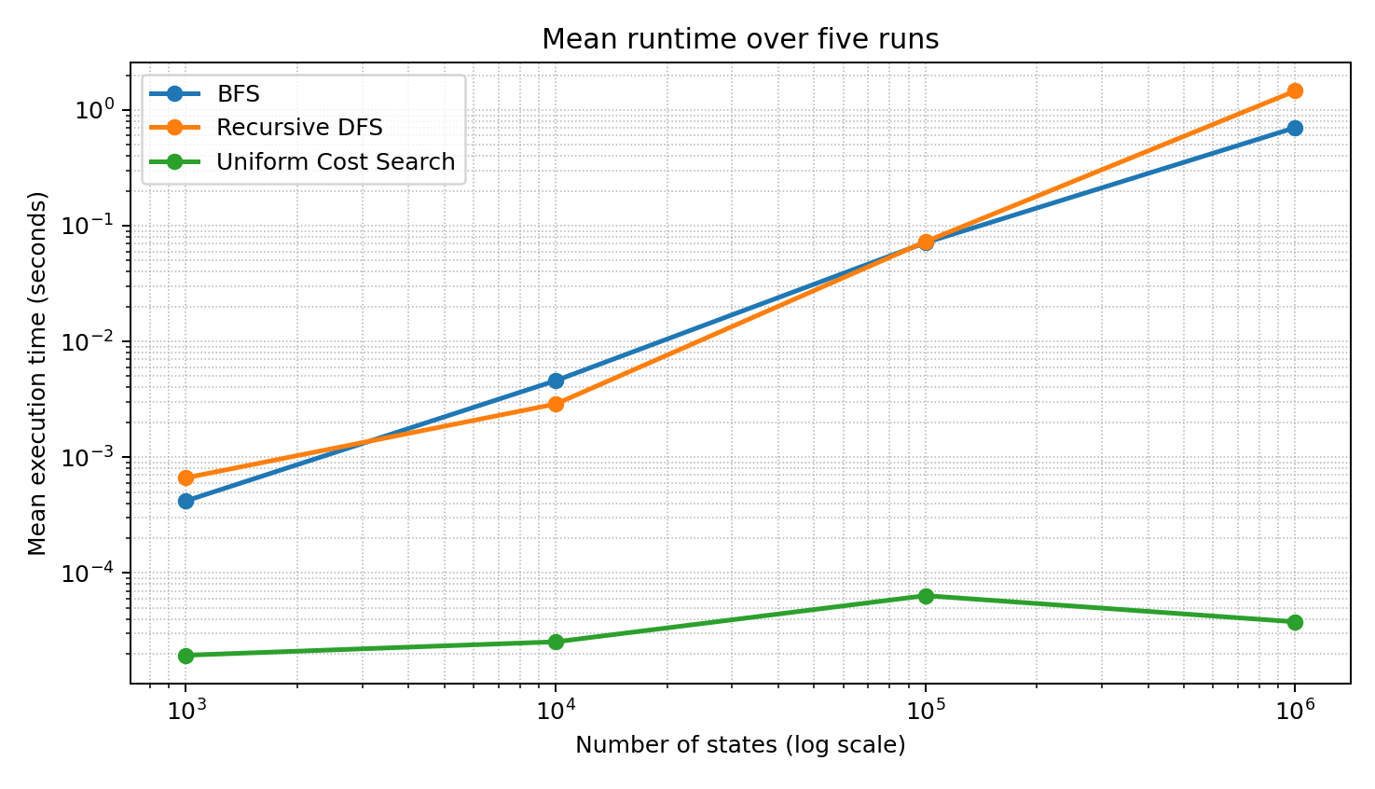
Figure 5. Mean execution time across state-space sizes (log-log axes).
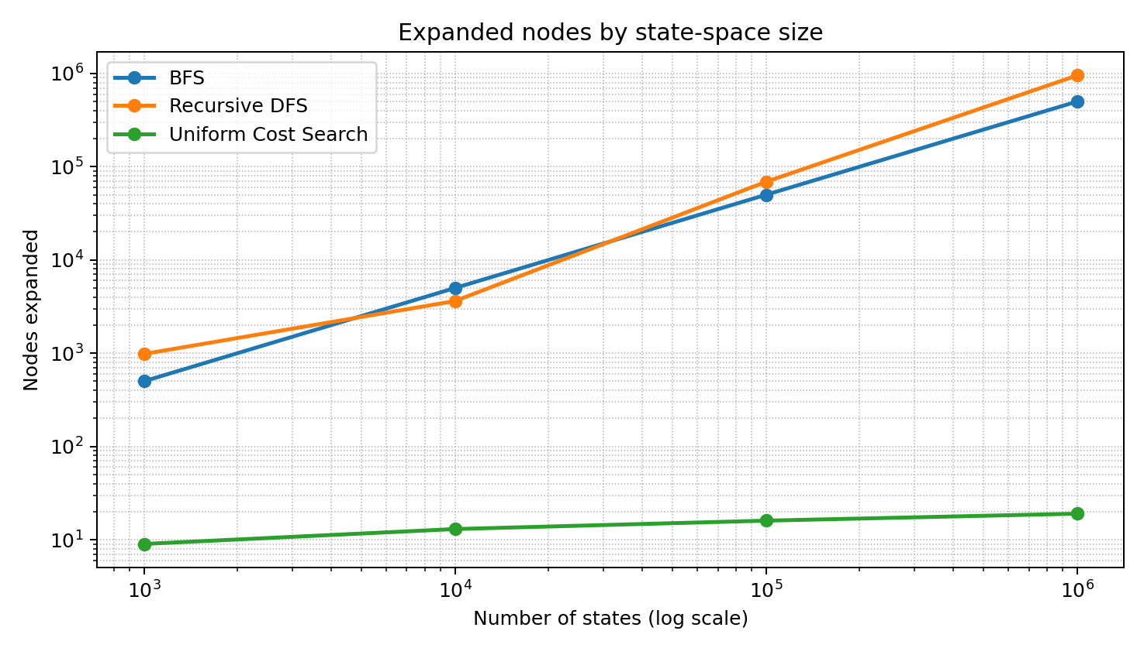
Figure 6. Nodes expanded across state-space sizes (log-log axes).
Interpretation of the measurements: BFS discovers all N states in this test tree and reaches a maximum frontier of approximately N/2. Recursive DFS uses a small active recursion depth (10–20 frames) but still explores many nodes and stores visited/parent data. UCS follows the deliberately low-cost goal path and expands only 9, 13, 16 and 19 nodes in these runs. This UCS result depends on the designed cost distribution and must not be generalized to every hospital graph.

11. Task 10 – Compare theory with experimental behaviour (4 marks)
- BFS generated nodes scale almost directly with N in this family: 1,000 → 1,000,000 states produced 1,000 → 1,000,000 generated states. Its maximum frontier also scales with N, matching the prediction that breadth can dominate memory.
- DFS generated 981, 3,626, 68,940 and 951,438 states. This non-smooth fraction reflects binary-tree shape and the target’s position in left-to-right traversal; it remains O(N) on this finite graph family.
- UCS generated 18, 26, 32 and 38 states and had a small frontier because off-route edges cost 100 while the unique goal route costs 1 per edge. The cost model is intentionally favorable to UCS; different weights can make UCS explore many more nodes.
- Timing generally increased with graph size for BFS and DFS. Small runs are dominated by interpreter and timer overhead; timing variation is why the five-run mean and standard deviation are both included.
- The theory is a worst-case bound, while experiments measure one graph family, one neighbor order and one target policy. The one-million-state test is not a proof of universal scalability, and the seed is recorded even though the constructed graph is deterministic.

12. Task 11 – Recommend and defend the final design (4 marks)
Recommendation: use Uniform-Cost Search as the route-planning baseline when travel-time costs differ, provided the graph is finite, edge costs are non-negative (strictly positive for the standard completeness argument), and the priority queue and duplicate-cost bookkeeping are implemented correctly. BFS should be retained as a simple baseline or used when all moves have equal cost and minimum number of moves is the goal. Recursive DFS is useful for illustrating low active-stack usage, but it should not be the primary cost-sensitive route planner.
Evidence-based defence: in the measured weighted tree, UCS expanded 9–19 states and kept a frontier of 9–19, compared with BFS expanding 500–500,000 states and reaching frontiers of 500–500,000. This is strong evidence for the chosen cost model, not universal proof. UCS’s worst-case heap and bookkeeping cost can be O((V+E) log V) time and O(V+E) memory. The robot should additionally use live obstacle updates, safety checks, replanning and a fallback policy if edge costs or localization change.

13. Task 12 – Day-4 design challenge (8 marks)

13.1 A. Impact analysis (2 marks)
The robot no longer knows one exact current junction after a restart or sensor fault. The fully observable and known-start assumptions are invalid. Its internal state must include its knowledge of the world: a belief state B, defined as the set of junctions where the robot may currently be. The robot must choose actions that succeed for every location still possible, or use sensing to reduce uncertainty.

13.2 B. Evaluate the original design (2 marks)
The original BFS, DFS and UCS algorithms can search a belief-state graph only after the transition model is changed. A state is no longer a single junction u but a set B of possible junctions. For k candidate junctions, there are up to 2^k subsets, or 2^k−1 non-empty belief states. Therefore the state space may grow exponentially in k. Applying the original algorithms directly to one guessed location is unsafe because the route may fail from another possible location.

13.3 C. Adaptation / redesign (2 marks)
Decision: MODIFY the design. Maintain a belief set, use local sensing to collapse the set to a singleton when possible, then run UCS from the observed junction to the pharmacy. If sensing is unavailable, perform belief-state search over the subset space and accept only a plan whose transitions are valid for every state in the current belief. In a worst case the belief-state search may have O(2^k) states and corresponding exponential time/memory; local sensing reduces the active planning state to one of k locations and then permits ordinary graph search.
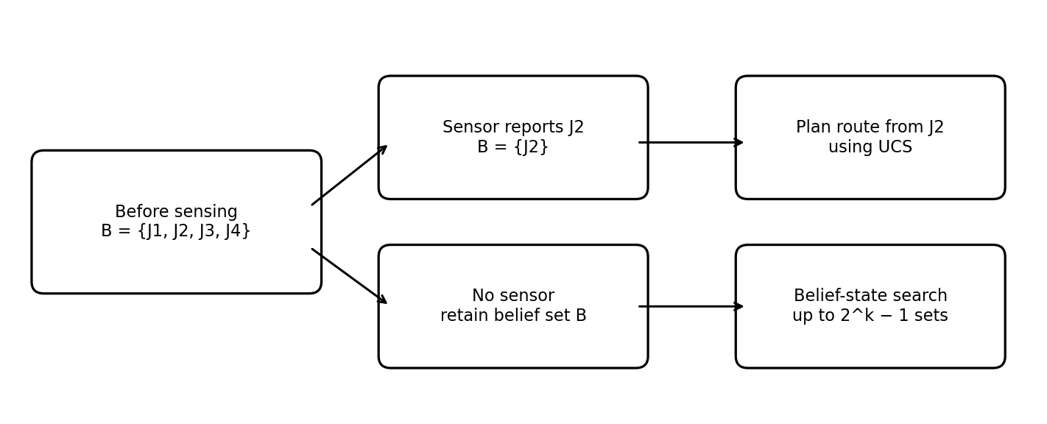
Figure 7. Belief-state idea: the robot tracks a set of possible locations until sensing resolves uncertainty.

13.4 D. Evidence-based defence (2 marks)
The included script src/belief_state_challenge.py enumerates all non-empty subsets as a worst-case belief-state representation and compares it with singleton beliefs when a local sensor identifies the current junction. The model uses a symmetric cycle without observation; no common fixed action sequence is guaranteed to dock from every ambiguous candidate position. With sensing, the robot knows which junction it occupies and can follow a shortest route of at most floor(k/2) moves on the k-junction cycle used for this illustration.
Table 10. Day-4 belief-state experiment results.
Candidate locations k | Belief states without sensor (2^k−1) | Singleton beliefs with sensor | Plan without sensor | Sensor plan upper bound
2 | 3 | 2 | Not guaranteed | ≤ 1 move
4 | 15 | 4 | Not guaranteed | ≤ 2 moves
8 | 255 | 8 | Not guaranteed | ≤ 4 moves

These counts are exhaustive representation counts, not a claim that every subset is reachable in every physical layout. The experiment demonstrates the exponential worst-case size and the reduction produced by a sensor. The output is saved in results/belief_state_output.txt. A real robot should combine sensor readings with confidence/uncertainty, stop safely if localization is ambiguous, and replan after new observations.

Appendix A – Source code and reproduction instructions
The complete executable source files are reproduced below and are also included separately in the src folder. The main program prints actual metrics and writes results/performance.csv; the Day-4 program prints the belief-state experiment.

A.1 Main search implementation (hospital_search.py)
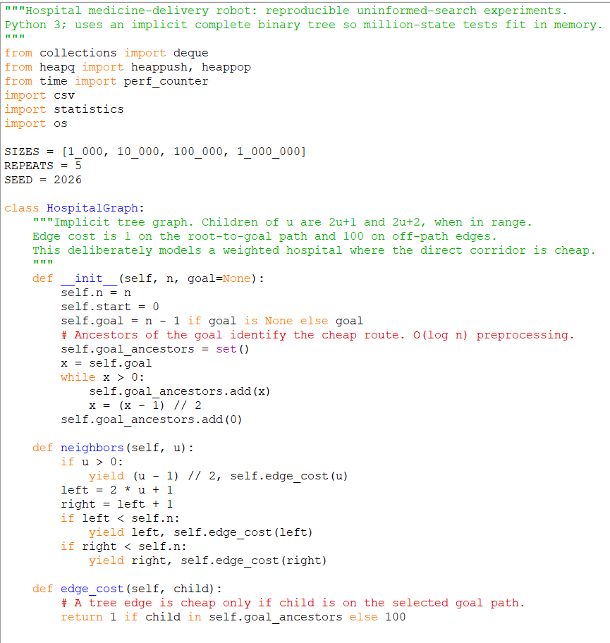

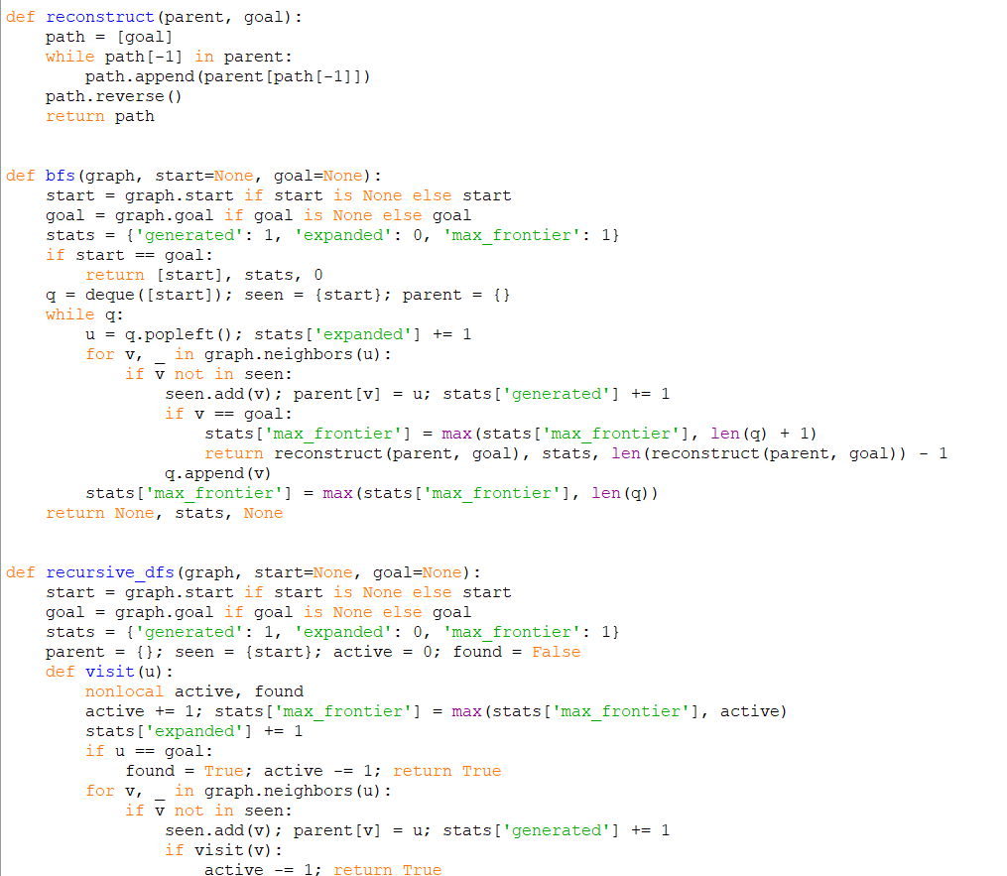
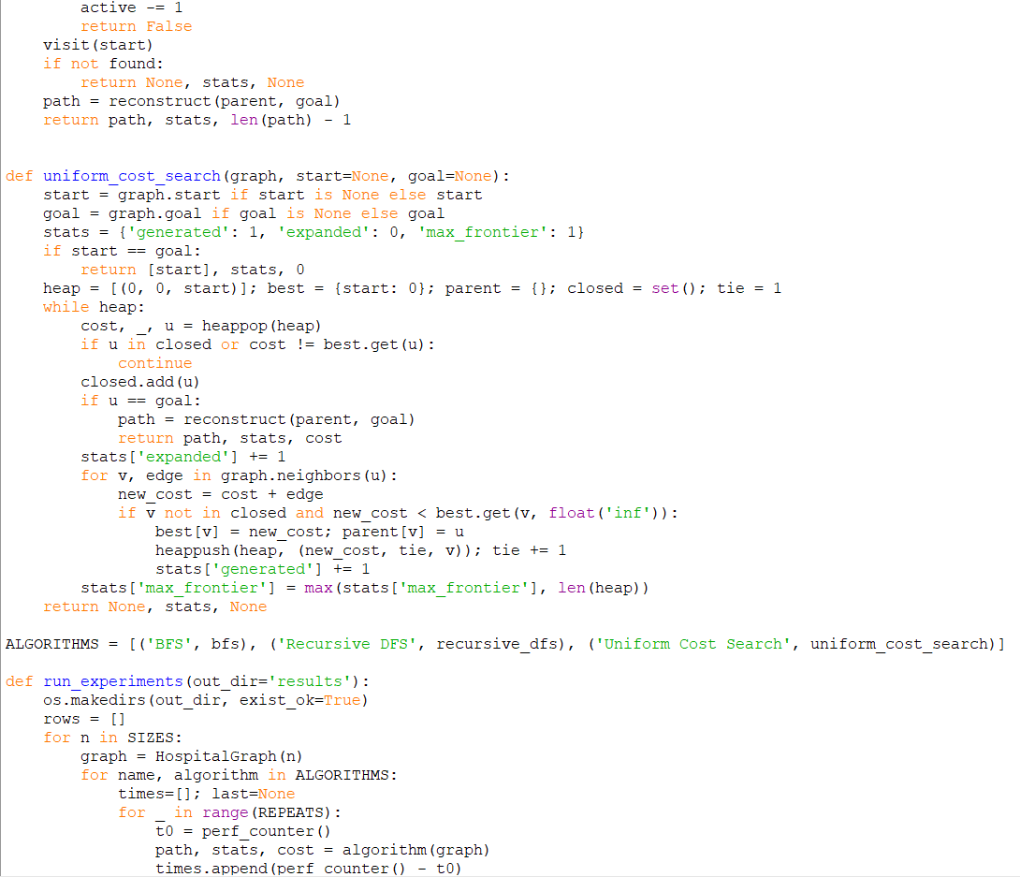
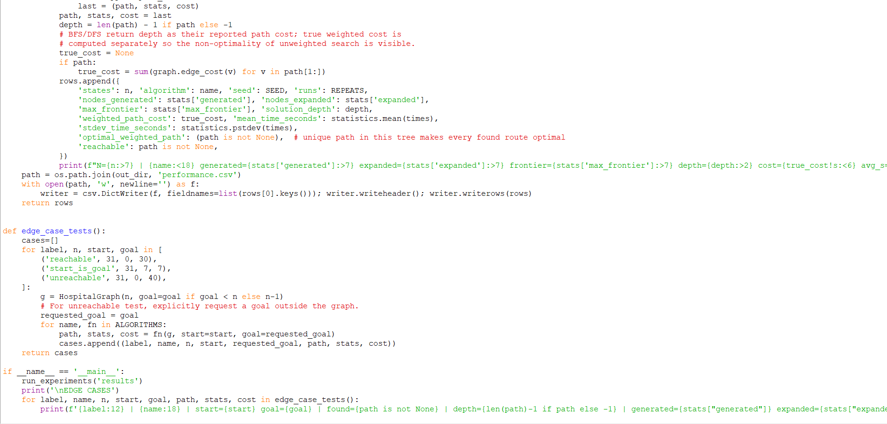
Output:
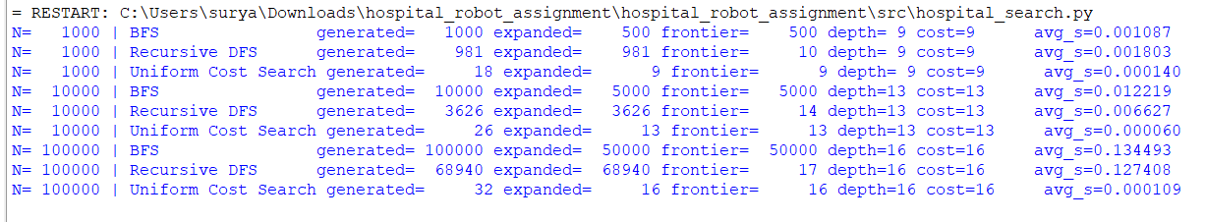

A.2 Day-4 belief-state implementation (belief_state_challenge.py)
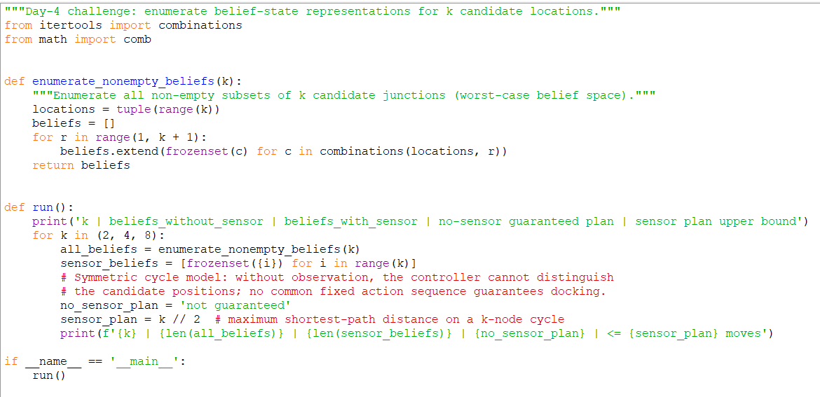
Output:

14. Conclusion
The assignment compared BFS, recursive DFS and UCS using explicit problem formulation, complexity derivations, a recurrence solution and reproducible Python experiments. BFS is complete and simple but its frontier can become large; DFS can use a shallow call stack but is sensitive to branch order and is not cost-optimal in general; UCS is the most appropriate baseline for non-uniform travel costs, although its performance depends on the cost distribution and priority-queue overhead. When localization fails, the design must be modified to reason over belief states and use local sensing where available. The experiment and its limitations are stated explicitly so that the evidence is interpretable and reproducible.

